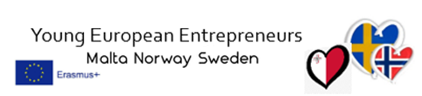
Disclaimer: Funded by the European Union. Views and opinions expressed are however those of the author(s) only and do not necessarily reflect those of the European Union or the European Education and Culture Executive Agency (EACEA). Neither the European Union nor EACEA can be held responsible for them.
Pedagogical Model for Young European Entrepreneurs:
The YEE project have developed, tested and evaluated a pedagogical model with 3 different phases;
Preparatory Digital Innovation Camp:
Purpose: To prepare participants for the upcoming mobility by introducing them to the subject matter and fostering creativity and problem-solving skills.
Outcome: Participants acquire basic knowledge and understanding of the chosen theme. They develop their business ideas and mentally prepare for the upcoming journey and the challenges that may arise.
Mobility (Trip):
Purpose: To provide participants with the opportunity to practically apply their knowledge and skills through workshops, study visits, and intercultural exchange.
Outcome: Participants have the chance to work in international teams, explore different perspectives, and learn from each other and experts in the field. They develop entrepreneurial skills and gain insight into global business practices and cultural differences.
Digital Follow-Up:
Purpose: To reflect on the experiences from the mobility, summarize lessons learned, and plan for future actions and projects.
Outcome: Participants have the opportunity to evaluate their progress, identify areas for improvement, and set goals for their continued development in entrepreneurship and international cooperation. Through digital tools, they can continue their interaction and learning even after the mobility ends.
Young European Entrepreneurs: A Successful Model for International Entrepreneurship!
Our pedagogical model is designed to provide participants with a comprehensive and rewarding experience that combines preparation, practical experience, and subsequent reflection. By following this model, participants not only develop their entrepreneurial skills but also open the doors to a world of global entrepreneurship and cultural exchange. With the Young European Entrepreneurs model, other organizations and projects can benefit from our successful experiences and create similar programs to promote entrepreneurship and international cooperation among young people.

